**Rotational Analyst Program: Case Study**

At ODC, one of our products measures the effectiveness of online advertising. To that end, we look at the differences in sales between households that saw the ad (“exposed”) and those that did not (“unexposed”).

**Problem Statement**: Using the attached set of data from a recent online campaign for a candy bar, we want to know if the advertising worked. Did seeing the ad change household purchase behavior? Is that consistent for all demographic and spending groups?

**Data:** The CSV contains a row per household, with columns containing data related to pre-period sales data, post-period sales data, demographics, online activity, and a flag for whether or not the household was exposed to the candy bar ad.

Pre-period sales data is aggregated over a quarter (13 weeks) and 5 quarters (65 weeks) are included in this data set, where Q1 is the most recent quarter and Q5 is the furthest back in time. Post-period sales data consists of sales during the campaign and in the 4 weeks following the campaign end.

Demographic data includes household income, the number of total individuals who live in the household, the number of children present, and the age of the person who does most of the purchasing.

Online activity data includes how many cookies are active in the household, the number of days a cookie was active, and the total number of times ODC saw the cookie.

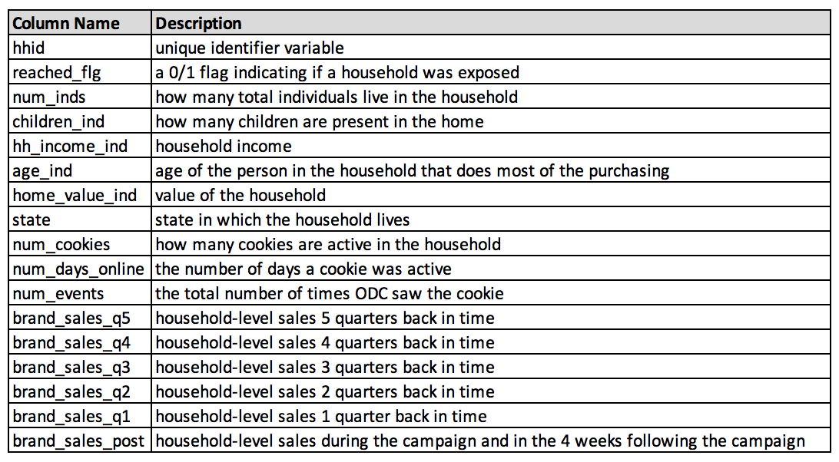

**Deliverable:** Put together a 10-minute presentation (Word doc, PPT, PDF, etc) with a compelling argument one way or the other. Be sure to support your argument with data, list any/all assumptions you have made, and include descriptions/reasonings for any models you chose. Your intended audience is a fellow data scientist who can follow along with your methodology, but wanted your guidance on next steps. Be prepared to walk through your presentation via a screen share with your interviewer during your scheduled time.

**Definitions:**

* Cookie: a very small text file placed on an individual’s computer that allows the company who placed it to identify the user at a later time
* Individual: a unique identifier for a single individual person, made up of one or more cookies
* Household: a unique identifier for a family or co-habitating group, made up of one or more individuals